

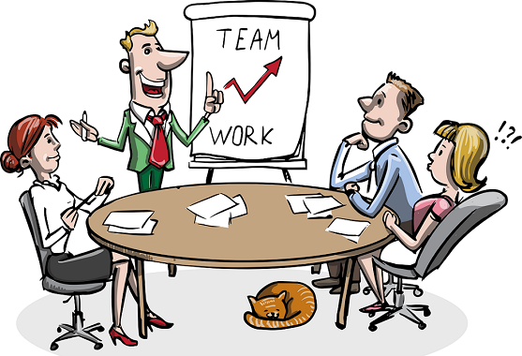

College of Business Administration
Master of Strategic Leadership Program

MSL502 Leading and Building High Performance Teams

Fall Semester AY2019-2020 Term A

TEAMWORK ORIENTATION (ASSIGNEMENT – 3)
Student Name | Soha Kayed Abu Moussa
Student ID No. | 1003948
Course Code and Title | MSL502 Leading and Building High Performance Teams
Course Instructor | Dr. Sanjay Singh
Course Section | 1
TEAMWORK ORIENTATION:
Teamwork orientation, it’s the level of individual and team contribution to which extent have a positive behavior and commitments towards working in a team effectively help to increase productivity to achieve the origination goal with high performance and outcome.

Purpose of the assessments:
The purpose of the assessments is to focus on discovering how we behave with individual or team toward the organization goal. It is a widely known that organizations built on the human how they behave based on different attitude or interaction of the individual. Throughout the assessments I examined the teamwork behaviors, the result provided me with a strong picture of knowing and understanding my strengths and the area needed for better development.
The assessments of effective teamwork have four elements such as translating the goals, engagement, collaboration and Monitoring performance needed to measure the behaviors with others.

Effective Teamwork Behaviors:
Excellent teamwork behaviors can develop the relationships between people with high productivity and create a successful workplace environment with flexibility based on the collaborative efforts. Positive teamwork requires understanding the goal, role with a clear picture of what required, with full respect and trust between each other, competitive effectiveness, creativity, innovation, motivation. Also, individual willingness to be accountable, hold responsibility and work together to support each other with high commit to the team to achieve a desired goal of the organization.

My Measurement Analysis:

 | Total Score | *TG | *ENG | *CB | *MPB
Range | 40-160 | 10 TO 40 | 10 TO 40 | 10 TO 40 | 10 TO 40
Outstanding | 151 | 37 | 38 | 38 | 38

*TG: Translating the Goal- * ENG: Engagement- *CB: Collaboration- MPB: Monitoring Performance

Four Elements of effective Teamwork Assessments

- Translating the Goal Behaviors Assessments:
My score on Translating the Goal is 37 outstanding, indicating that as a leader, I have strong trust of my capability, qualities to achieve a desire goal. I do understand the organization goal very well and translated to the team effectively by defining the responsibility and duties for each member. Also, I clearly set the department Strategic planning, goal, vision and mission with the expectation of ensuring the support for the team to meet the goals for each employee performance outcome. I always influence them to understand the effectiveness of their contribution and how it’s important for better achievement of the goal. Measures of individual performance by aligning the behaviors with the organization goal to achieve the standards successfully as teamwork. Making my actions consistent with my promises by being trustworthy

Area for improvement:
In question number 10, I scored 2 out of 4. The result shows that I need to focus more on developing competitive activities or motivational system among the team member to encourage them to increase productivity with high performance to work together not against each other.

How will I achieve it?
By developing internal department competition process for the team members to encourage them to compete to achieve high outcome as a team. I must create many activities and competition it can be daily or weekly and monthly. For example, create the monthly best employee performance competition and share the daily progress report in a different area to develop the skills of the team, this will help in increasing the commitment and loyalty with high positive impact.

- Engagement Behaviors Assessments:
My score on Engagement is 38 outstanding, indicating that the environment of the teamwork must support through encouragement and the sharing any new ideas, delegate, empower, providing positive feedback and taking and providing constructive advice which leads to better levels of productivity. Team building by Involving the team in more activities to build trust and a strong feeling of belonging within the team with a clear understanding of the strategic planning to meet the goal. Also, I make sure that I give the importance for every member of the team. The employee is the main asset of the organization success to share their feedback, new information and focusing on their talents and creativity to develop the organization in an innovative way, this will increase the advantage of cooperative work engaged on as teamwork done as a group. I am as a leader I focus on developing and engaging the team effectively with equal communication with each member. However, when we make employees feel they are valued, have the right to suggest new ideas, sharing knowledge will be more motivated, engaged and being a member of a successful team is a motivational process to meet the expectations of a common goal successfully. Although engage the employee by identifying the importance of running the project or assigned task with positive impact on our organization, a clear vision and strategy. Also, by monitoring and evaluating will help to understand the importance of the task, definitely this will help to take the right action at the right time assigned the right person to achieve the target with respect to different cultures.

- Collaboration Behaviors:
My score on Collaboration is 38 –Outstanding. The result indicating that as leader I have a strong ability to manage and lead the team in an effective way. Collaboration means that working with others together to accomplish a common goal and encourage transparency. I support the team member by providing the important of a clear criterion before members collaborating to take any decisions. Also, seeking the feedback and agreement of the team before implementing any strategic decision and let them understand the importance of the process based on the effective team. Their corporation will help in setting clear responsibilities to avoid any conflict with a quick decision to adapt to any new changes and implementation. Definitely, by giving the team the chance for open discussion of any issue will guide for better collaboration as it will be very clear that it’s for the team benefit to develop and have the opportunity to contribute effectively.

- Monitoring performance Behaviors

My score on Monitoring performance is 38 –Outstanding. The result indicating that as I leader I have strong abilities to monitor the team performance by checking the progress of the team daily toward the target or the goal by doing the evaluation of each members which leading to recognition or taking an action, coaching, follow-up for better development and improvement. By providing the feedback for individual performance and area need improvement to increase productivity. At the same time, I do recognize the best performance to motivate them to keep up the high progress by celebrating in front of other team member to encourage them for better achievements to meet the performance expectation or standards. Through the measurement I can address the gaps and barriers to avoid any conflict or poor performance in future. However, understanding the problem help for better planning, solving the issue, making a decision and better control of the situation this will support the team to be more innovative.

Conclusion:

To be an Excellent positive leader, we should have a High Quality, a clear goal, abilities to manage the teamwork effectively with creativity in work and innovative ideas. Professional Communication and skills development with respect to others. Also, Work smart on value by taking in consideration the importance of other culture, diversity, emotion, uphold ethics, meet our promises, less suffering from stress, awareness of external/Internal factors organized work, increase participation, flexibility and Simplify ways. Although, fail is an opportunity to learn from mistakes and inspiring strength toward high achievement of the team with motivation to myself and others to drive the goal successfully. My vision is that Internal positive environment leads to external happiness and highly satisfied customers.

